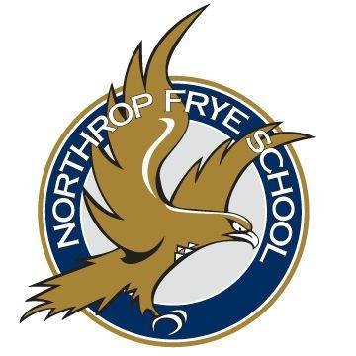
Northrop Frye School
Bursary Application Form
Applications due June 14th to nfshomeandschool@gmail.com
General Information:
Name: _________________________________________________________________________________________________
Address: ______________________________________________________________________________________________
Phone Number: ________________________ E-mail: ___________________________________________________

Education Information:
Years attended Northrop Frye School: _____________________________________________________________
Name of College/University you are attending: ___________________________________________________
Anticipated Course of Study: _______________________________________________________________________
How many years is the program?: _____________ Level of Education sought: ____________________
Desired career or occupation upon completion of post-secondary: _____________________________

Extracurricular:
Please list any extracurricular activities you are involved in:
- _________________________________________________________________________________________________
- _________________________________________________________________________________________________
- _________________________________________________________________________________________________
- _________________________________________________________________________________________________
- _________________________________________________________________________________________________
- _________________________________________________________________________________________________
At Northrop Frye Home & School, community building is a key part of who we are and why we do what we do. Please use the following space to tell us about your involvement/contribution to your community. This can either be your school community or your community at large. Please list any volunteer contributions as well.

