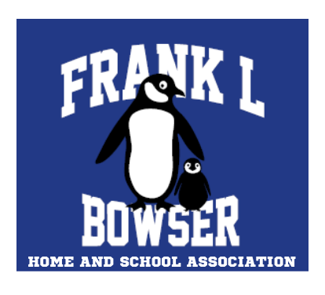

Frank L. Bowser Home and School - FLB Alumni Bursary

The FLB Alumni Bursary is provided by Frank L Bowser Home and School to an FLB alum graduating from Riverview High School. Two $500 bursaries are awarded in June of each year. Bursary winners are selected by the Frank L Bowser Home and School executive committee.

FLB Home and School members believe deeply in the value of teachers. Our teachers make a monumental impact on the lives of our young community members. To recognize their value, bursary applicants are asked to describe how an FLB teacher made a difference in their lives.

Applicants must have attended Frank L. Bowser School and be graduating from Riverview High School this year in order to be eligible. Recipients are selected based on the content and quality of their applications.

Completed applications must be submitted to franklhomeandschool@gmail.com before May 25, 2026 for consideration.

(application form below)

Frank L. Bowser Home and School - FLB Alumni Bursary

NAME:
ADDRESS:
PHONE:
EMAIL:

What post-secondary program do you plan to study?

Where do you plan to study?

Briefly describe your career plans and what you intend to do with your degree.

What are you most looking forward to achieving? Why/how is your selected career/intended course of study valuable and/or meaningful to you?

What activities were you involved in at Frank L. Bowser?

What community activities/events/projects have you participated in?

FLB Home and School believe deeply that teachers make a monumental difference in our lives. Please describe in approximately 1-3 paragraphs how a Frank L. Bowser School teacher made a positive impact in your life. How did they make a lasting impression on you? What would you say to them now as a graduating student?

