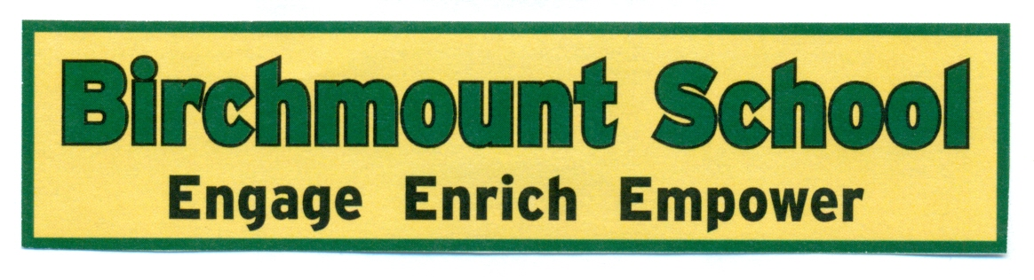

Birchmount Home and School Association
Bursary

April 20, 2026

Dear Guidance Department:

On behalf of the Birchmoint Home and School Association we are pleased to inform you that a Bursary of $500.00 will be offered to a current grade 12 graduating student who previously attended Birchmount School.

Eligibility requirements are as follows:

• Must have attended BIRCHMOUNT SCHOOL at some time during their elementary or Junior High/Middle School years
• Must be presently attending a Moncton District High School
• Must have a 75% minimum academic achievement in grade 11 and 12
• Must have/be contributed to extracurricular activities while attending both Birchmount School and present High School
• Must plan on attending an accredited university or other post-secondary institution on a full-time basis
• Must include in their application an accompanying letter giving particulars of the student’s interests, activities (school, community, part-time work, etc.) as well as reason why they should be chosen to receive the Birchmount School Bursary
• Enclose a copy of transcript of marks from Grade 11 and last report card of Grade 12 year

Deadline for this bursary is Friday, June 5th, 2026. Our committee, comprising of Birchmount Home and School Association members will review the applications and your department will be notified by Friday June 12th, 2026 with the results should one of your students be the recipient.

If possible, we would prefer that the candidate not know the results until the announcement is made at the graduation.

Sincerely,

Lisa Bourgeois
President

APPLICATIONS TO BE SENT TO:
Birchmount Home and School Association
c/o Birchmount School
256 Ayer Ave.
Moncton, NB
E1C 8G8

Birchmount Friends of the Bears Bursary Application Form

Name: _______________________________________ Age: Male ◻ Female ◻

High School:

Address:

Postal Code: _______________ Phone: ___________________________

Parent(s) or Guardian:

Number of siblings: _____

Schools attending and grade levels

Year(s) you attended Birchmount School: ______ From grade: to grade: ______

Have you had any involvement with Birchmount School since leaving? Yes ◻ No ◻
If yes, please explain:

Post Secondary School to which you have been accepted:

Field of Post Secondary Study:

Have you received a scholarship and/or other bursaries? Yes ◻ No ◻

If yes, how much $______________

In a typed letter accompanying this application, please give particulars about yourself. Outline information on extra-curricular activities you were involved with while at Birchmount and throughout your High School. This should also include any achievements/award/competitions and also any community involvement. Also, include reasons for your extra-curricular involvement.

A transcript of marks from Grade 11 and your last report card of Grade 12 year must accompany the application.

APPLICATIONS TO BE SENT TO:

Birchmount and School Association
c/o Birchmount School
256 Ayer Ave.
Moncton, NB
E1C 8G8

******** Deadline for receipt of applications is June 6th, 2025 ********

