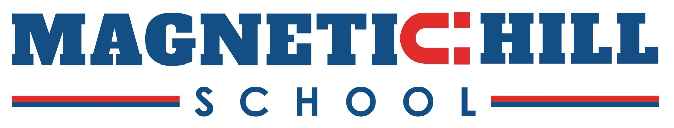

May 8, 2026

Dear Guidance Department,
On behalf of Magnetic School Staff, we are pleased to inform you that 2 bursaries of $500 each and 1 bursary of $250 will be honored for three students graduating from Harrison Trimble High School.
Eligibility requirements are as follows. Applicants:
- Must have attended Magnetic Hill School at some point during their elementary or middle school years
- Must be presently attending Harrison Trimble High School
- Must have a 75% minimum academic achievement in Grade 11 and 12
- Must plan on attending an accredited university or post-secondary institution
- Must include an application, an accompanying letter giving particulars of the students’ interests, activities (school, church, community, part-time work, etc.), as well as a reason why they should be chosen to receive the Magnetic Hill bursary
- Must enclose a copy of transcripts of marks from grade 11 and most recent report card of grade 12
The deadline for this bursary is Friday, May 29th, 2026. Our committee will review the applications and your department will be notified by Friday June 5, 2026 with the results.
The chosen recipients will be notified also by the committee.
Sincerely,
Wendy Murray and Nancy Dufort, on behalf of Magnetic Hill School Staff

Application is to be sent to:
Magnetic Hill School
c/o Nancy Dufort
3346 Route 126 Highway
Lutes Mountain, NB E1G 2X4

Application for the Magnetic Hill School Bursary, 2026

Name: _______________________________________ Age:

High School:

Address:

Postal Code: _______________ Phone: ___________________________

Parent(s) or Guardian:

Year(s) you attended Magnetic Hill School: ______ From grade: to grade: ______

Have you had any involvement with Magnetic Hill School since leaving? Yes No
If yes, please explain:

Post Secondary School to which you have been accepted:

Field of Post Secondary Study:

Have you received a scholarship and/or other bursaries? Yes No

If yes, how much $______________

In a typed letter accompanying this application, please give particulars about yourself. This should include any achievements/award/competitions/extracurricular activities and any community involvement.

A transcript of marks from Grade 11 and your last report card of Grade 12 year must accompany the application.

APPLICATIONS TO BE SENT TO:
Magnetic Hill School
c/o Nancy Dufort
3346 Route 126 Highway
Lutes Mountain, NB E1G 2X4 Deadline for receipt of applications is May 29, 2026
******** ********

